Lead
Call Out Problem | What does it take to consistently win in the stock market?  I’m not talking about hitting a couple big trades every now and then…  Or having a few good years during a “can’t lose” bull market…  I’m talking about year in, year out, making a full-time income from your investments…  WITHOUT taking huge risks that make you feel anxious, stressed out, and constantly worried you could lose it all in mere minutes.  WITHOUT having to constantly monitor the markets every day and be ready to trade at a moment's notice…  And WITHOUT having to sacrifice the lifestyle you want to live… or be forced to move to a third world country... because that’s all you can afford.
Promise Solution to Pain Point + Promise to Save Time/Money | Is it luck?  Because if luck had anything to do with it…  Wall Street banksters – like JP Morgan – wouldn’t be so filthy rich.  In 2017, they only had 4 losing days in the market… and that was a BAD year for them.  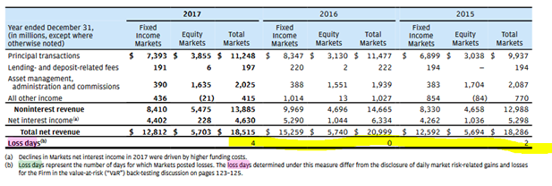  In 2015, they only had two losing days...  And in 2013, 2014, and 2016? They had a 100% win rate!  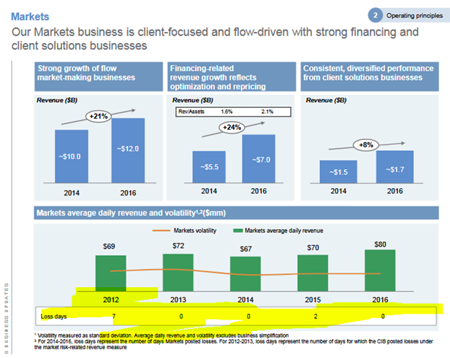  WTF?!  That means out of 1,260 trading days…  Only 6 of those days were losers.  That’s a 99.52% win rate…  With an average of $71 million in trading revenue per DAY.  But according to blow hard economists and PhDs everywhere…  It’s “impossible” to consistently beat the market.  But the truth?  An elite group of traders beat it every single day.  Do you need “three simple trading patterns?”  According to all the internet gurus…  All you need to make your millions is to draw some triangles on charts...  Wait for an “X” to form...  And “BOOM! You’re rich!”  If only it were that easy...  Because if it were, I would’ve become a stock market millionaire way sooner than 25 years old…  I’d have made tens of millions more for myself - and my clients - over the past 20+ years...  And I sure as hell wouldn’t be telling ANYONE about it.
Tease Emotional Discovery Story | Or do you need something that’s been kept secret from you by an elite group of people?  People who’d rather you DON’T know how to quickly - and safely - multiply your money…  People who are NOT “smarter” than you... yet somehow seem to ALWAYS be on the right side of the trade.  People who DON’T “deserve it” more than you do… but seem to live life the easy way when so many people have it hard.  And it’s all because they have something you don’t…  A proven system that works in any market condition!  Look. You don’t have to settle for 5% - 10% gains in the stock market every year...  The truth is, everyday people – just like you – can grow their accounts by 20%, 50%, even 100%+ every single year…  But most people NEVER WILL…  And it’s all because they believe a lie they’ve been told by the people who were supposed to help them.
Tease Unique Mechanism Behind Solution | A lie that’s helped Wall Street insiders  swindle hard working Americans  – just like you –  out of the money they deserve to have  And today, I’m going to reveal the dirty secret that hedge fund managers don’t want you to know…  A secret your financial advisor wishes they knew…  And a secret the mainstream media will do anything to cover up.  Why?  Because the powers that be want you to be addicted to the 24-hour news cycle so you’re easier to control…  They want you to believe investing is hard, and you should leave it up to the “professionals” to do it for you…  And most of all, they want to shear you like a sheep – every single year – so they can live large while you live small.  But the truth is...
Tease Contrarian Nature of Mechanism (This Flies in the Face of What You’ve Been Told Before) | Investing can be fun, simple, and highly profitable once you have The F.A.S.T. Money Method on your side…  It’s the reason I was earning more than a million dollars per year in my early twenties….  It’s the reason I’ve been able to earn my clients hundreds of millions of dollars in returns...  It’s the reason why my subscribers have had the chance to bank F.A.S.T. Profits like…  - 121% in 65 days on Carbonite (CARB)...  - 70% in 60 days on Boot Barn Holdings (BOOT)...  - 115% in 17 days on Lexington Realty Trust (LXP)...  - 97% in 76 days on HQY/NVS...  - 61% in 28 days on British American Tobacco (BTI)...  And it’s the reason I keep getting amazing success stories from people who’ve seen life changing gains in record time.  People like Frank F. who’ve doubled their account since they started using this strategy...  “My portfolio is up over 100% since January 1st… increasing from roughly $23k to $50k is the first really spectacular success I’ve had in the stock market”  Or Bez B who doubled his account in one month after losing his job...  “In February, having lost my job in January, I paid some of my end of service money into my trading account and have doubled that value in one month. I am so grateful to Chris.”  Or Russel G who has almost tripled his account…  “Account has doubled and almost tripled. I need this for retirement”  And Keith B, who’s booked $40k in PROFIT in only six weeks...  “I am pinching myself to make sure this is actually happening to me. Even though I am still conservative with my trade size I've booked about $40K in profit over the last 6 weeks.”  – Keith B.  And Jay W. who’s up $79,600…  “I’ve made more money in a shorter time than I thought possible… $79,600 to date”
Working in “Fascinations” as Incentive For Continuing With Copy (I’ll Answer This Riddle For You) | So, if you’re willing to keep an open mind…  In the next several minutes, I’m going to take you behind the scenes and show you how to...  Consistently land fast moving double digit - and triple digit - winners…  Double, triple or even 10x your portfolio over the next 3-5 years…  Explode your portfolio by more than TWELVE THOUSAND, FIVE HUNDRED PERCENT over the next 15-20 years…  And have the chance to turn every $10,000 invested into a life changing $1,264,235.  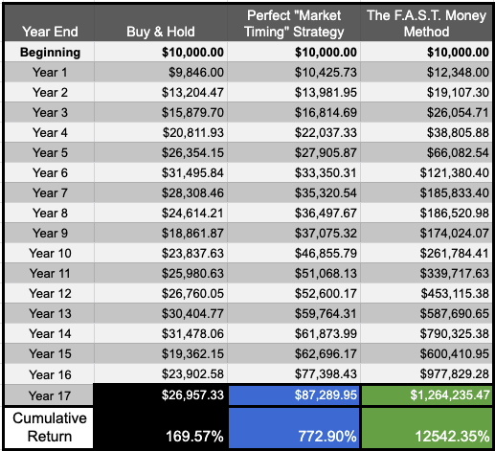  Holy SH*T!  Which means it doesn’t matter if you’re still trying to figure out how to save enough to afford retirement…  Or you’re retired right now and you’re looking for extra income…  The F.A.S.T. Money Method can help you get the kind of returns you need to retire early, retire now, and stay retired forever.
Briefly Address Skepticism | Now, I know that might sound crazy…  Because it seems like everywhere you turn, there’s some new stock market guru promising to make you rich…  And show you how to get 1,000%+ returns in 15 seconds or less.  But you and I both know that if they really could do that…  They’d never tell you about it.
Is it new/different? | What I’m about to reveal to you today is like nothing you’ve ever seen before.
Is it volatile? | You won’t need nerves of steel to handle trades that could go up 400% one day and go to zero the next….  Because I like to sleep soundly at night…  And there’s no way I could do that if I was risking my family’s future on something that volatile.  But thanks to this little known “backdoor” into the stock market…  I’ve shown my students how to consistently land double - and triple digit - winners WITHOUT all the risk…  People like Robin J, who wrote in to tell me...  “[Chris Rowe helped me] by keeping me safe, which provides confidence. I own three stocks which are less than 4 months ‘old,’ and the gains are 29%, 34% and 62%.
Is it easy? | You won’t have to make any complicated options trades or futures plays.  If you know how to buy a stock or ETF, you can use this strategy and get some amazing gains.  And of course, if you’re comfortable buying or selling simple – and safe – call options…  You can use this system to amplify your gains – and reduce your risk – in ways you can’t possibly imagine.  Which is what happened for one of my readers named George who wrote in to tell me...  “I have just this past week bought and sold Call options on INSEEGO and Alibaba and have made 100% and 60% in two days respectively. On INSEEGO options I have made 500% since December. I now get in, get out, and out and pocket my profits.”  Not bad for a couple days work, right?
Is it low hassle? | You won’t have to glue yourself to your computer.  Because it doesn’t matter if you’re brand new to trading…  Or you have decades of “in the trenches” experience…  You’ll never have REAL FREEDOM - no matter how much money you have - if you’re constantly watching the markets…  Worried you’re gonna miss out on a much needed winner…  Or terrified you could lose it all at a moment's notice.  But when you’re using the FAST Money Method, not only will you protect yourself from unnecessary losses…  You can actually turn them into huge winners, which is exactly what happened with one of our readers, Joe C.  “I signed up hoping to retire early - I’ve got a family I want to spend time with. I would have lost $1,300 on my positions. Because of what I learned through Chris, those add up to over $4,000.”  Besides. Day trading sucks.  And even though it sounds sexy to 10x your money in a single day…  I have no interest in day trading…  And I’m guessing you don’t either.
Do I need prior experience? | You DO NOT need any prior trading experience whatsoever...  And in this presentation, I’m gonna assume you have no knowledge about the markets or how to trade them.  If you’re completely clueless about any of this stuff, all the better actually.  I’ve found, in my nearly 20 years of teaching people how to trade...  It’s usually the people with the most trading experience that have the hardest time learning something new.  So while they’re busy unlearning their biggest mistakes...  You’ll be learning how to trade the right way from the very beginning.  And I love hearing from stock market newbies like John Jordan, who wrote in to tell me...  This is FANTASTIC. [My wife and I] are brand new to the stock market. You make this so easy and exciting for us.  As well as long time investors who’ve like David C, who recently told me…  “I have been investing for 3 decades and this is the best [strategy] ever. Nothing comes close. Plus it’s so simple that I am confident putting real money into it. My returns have been incredible - life altering. Thanks again.”
Open to everyone | You don’t need any sort of special accounts… have any insider connections… or be “rich already”...  All you need is an internet connection...  A few thousand bucks...  And access to any online brokerage account that can trade US stocks, bonds, ETFs, and mutual funds…  ...which means you can also use this strategy for your retirement accounts, like an IRA, 401k, 403b, Roth accounts...  ...Your health savings accounts (HSA)  ...or even your kids – or grandkids – 529 college savings plan!  I have doubled my 401k holdings in 5 years. I couldn't have done it without Chris.”  JOHN S.  Which means it doesn’t matter if you’re still trying to figure out how to save enough to afford retirement…  You’re retired right now and you’re looking for extra income…  Or there’s other important people – or causes – you’d like to be able to support.
Only | The F.A.S.T. Money Method is the ONLY system you need if you want to make a full-time income “working” less than a few hours a week.  Because the key to this system is simplicity!  Now, I’m not gonna lie to you and pretend like this is “set it and forget it” simple...  But if you follow a few simple principles…  All it takes is - at a maximum - five hours a week to manage.  But once you’ve got it up and running… and you’ve gotten comfortable with how the strategy works…  You can manage your entire portfolio in literally MINUTES each week.  Which means you’ll finally have the chance to experience the kind of freedom that's normally reserved for only the super-rich.  And you can do it starting today.  In just a moment, I’m gonna show you how The F.A.S.T. Money Method works…  But before I do, I should probably tell you a little bit about me…  And why you should listen to anything I have to say.

Background Story
Who I Am + Credibility Builders When Appropriate (ie. A Doctor or Expert) | Hi. I’m Chris Rowe.  And over the past 25 years, I’ve personally earned tens millions of dollars trading…  As a professional money manager, I’ve helped generate hundreds of millions of dollars in returns for my clients…  And thanks to the dozens of courses and financial newsletters I’ve been involved with for the past 17 years…  I’ve helped tens of thousands of people gain the confidence they need to manage their own investments…  And grow their accounts faster than they ever thought possible.  But the thing I’m most proud of? Being a great husband, father, and family man.  Because what’s the point of making all that money if you don’t have someone to enjoy it with?  [Show some family photos]
“Me or Someone Close to Me Was Just Like You (In Pain)” – Here’s The Emotional Story About It | And I don’t say any of this to brag…  I say it to prove a point.  It doesn’t matter what your circumstances are right now…  If you know how to trade stocks, you can live the lifestyle of your dreams.  Because I didn’t start life with a silver spoon in my mouth.  And I wasn’t born with any sort of special circumstances that made life easier for me.  I grew up in a middle class family in Queens, New York…  My parents got divorced when I was young…  And when I was 15 years old…  I found myself in the wrong place at the wrong time, took a knife wound directly into my spine, and was paralyzed from the waist down.  I can still remember the doctors telling me not only would I never walk again…  But I’d never be able to have a family either.  And yeah, in case you’re wondering…  That wasn’t exactly the best day of my life.  I mean here I am, in high school, thinking I have my whole life ahead of me...  And thanks to a mistaken case of identity…  I got stabbed in the spine and was put in a wheelchair.  And as much I want to give you the cliche story about how I decided right then and there I wasn’t gonna be a victim of my circumstances…  And how I vowed to be rich and set off towards greatness…  I had to go through a lot of pain and a lot of anger before I got there.
Traditional Solutions & Advice Not Working | So, like any hormonal teenager would...  I started getting into all kinds of trouble with some kids from the neighborhood.  I couldn’t give less of a crap about school…  And at the rate I was going, it was pretty clear my life was headed for something dark and dangerous.
Trigger Event – Problem or Pain Point Escalated to Where Avatar Realizes Something MUST Change | Then, when I was 17 years old…  In an instant, my life changed again.  I was at a BBQ with my mom and a family friend who worked on Wall Street said to me...  “Whenever you’re ready, come work for me.”  Growing up…  I thought I was gonna go to college, get my degree, and go work on the Street after I’d gotten to live a little…  But clearly, life had other plans for me.  So when someone was willing to give me a chance...  I didn’t waste another minute feeling sorry for myself.  When we got home from the BBQ…  I told my mom I was ready right now.  Somehow, I convinced her to go along with my plan to graduate high school 6 months early...  Skip college entirely…  Pursue a new life on Wall Street…  And earn the kind of money that would help me take back the freedom I felt I lost just a few years before.
Search for Truth/Answers | I started my senior year of high school with a fire lit under me…  Not only was I doing everything I could to make sure I graduated early…  I was devouring anything and everything I could find to learn the secrets of the stock market.  And one day, when I was at my godfather's house…  I found this gigantic book that had stock charts of all 500 companies on the S&P.  So, with nothing else to do, I studied every single chart in that book…  And all of a sudden, things started to click.  I started to notice weird things about the way certain stocks moved…  They didn’t all go up or down at the same time…  But for some reason, all of the stocks in the same sector seemed to move up or down at the same time.  Now, keep in mind, this was the early 90’s…  ...so I didn’t have the internet, access to the 24/7 financial news media, or even a cell phone.  Which, in hindsight, was a blessing in disguise.  You see...  Most people get way too caught up with the story around the stock.  They get tricked into believing the hype about the tech…  They get fooled by the CEO and their past success…  They waste tons of time reading financial statements and focusing on all kinds of useless information.  But I didn’t have any of that stuff to cloud my vision…  The only thing I had to look at was a stock chart that told me what the price of the stock was…  And how many shares were being bought or sold.  After a while, it started to feel like I could see something in those charts…
Optional: Meets Wise “Sensei” Type Who Promises to Reveal the Truth That’s Been Hidden. | A secret that would one day make me  richer than I ever imagined...    There’s me, at 17 years old, dreaming of striking it rich at my first desk on Wall Street  And a few months later when I started my new career on Wall Street…  I found the “missing piece.”  Thanks to a lot of persistence, and a little bit of luck…  I managed to convince one of the top traders at my firm to mentor me.  A man who’d started from nothing and was now worth hundreds of millions of dollars...  And from him, I learned the shocking truth about the stock market I couldn’t believe was real…  Because what he told me seemed completely unbelievable.

Mechanism / Problem
Explaining the “Real Cause” of the Problem; You’ve Had 99% of the Answer But This is the Missing 1% | “All those stock charts are fake!”  I had to ask him to make sure I was hearing this right…  Are the things we see in the newspaper… on TV… and from the companies themselves literally “not real?”  An illusion most people don’t even know they’re trapped inside of?  A well orchestrated conspiracy by the so-called powers that be?  Well, that might be the case, but that’s not what he meant…  So he clarified and told me...  “Most people think the major indexes… like the S&P 500, the Dow Jones Industrial Average, or the NASDAQ are somehow ‘the market’...  But they’re not!  And if you want to make real money in this business, you need to be trading on the TRUE MARKET”  That’s when he showed me a chart that looked like this…  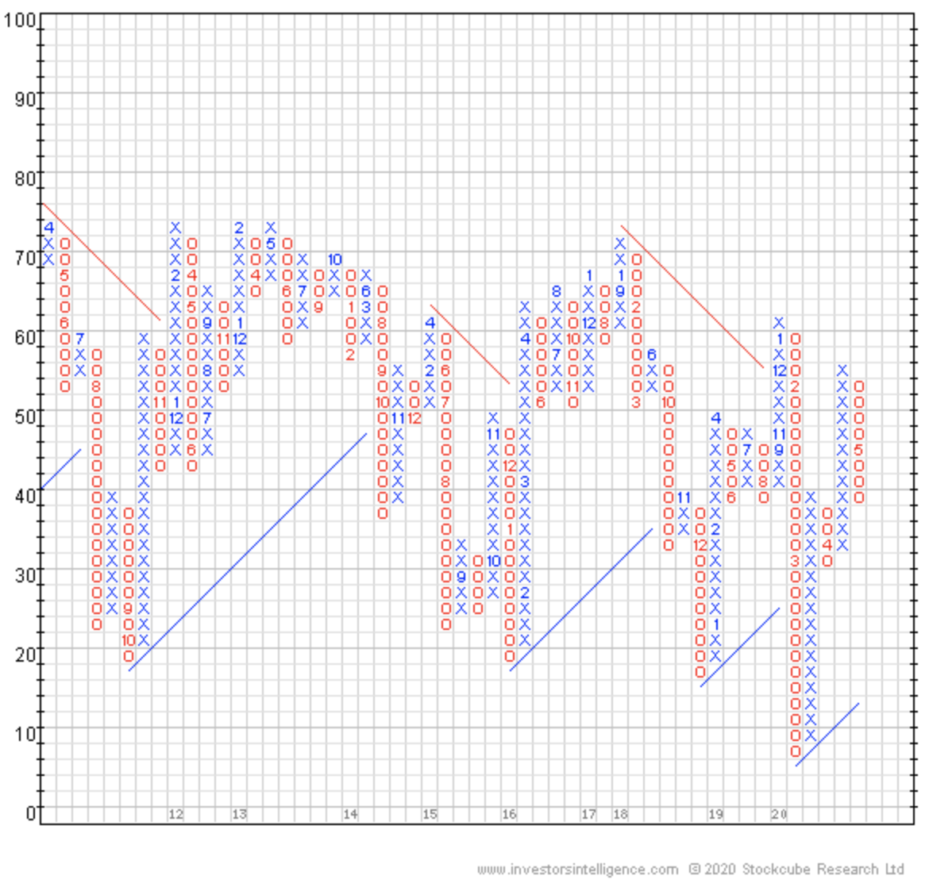  I’d never seen anything like it...  But I could tell I was about to learn something incredible…  So I asked him to tell me more…  He said to me...
Should Be Surprising, Possibly Even Counterintuitive | “I know this might sound crazy…  But the price of a stock has almost NOTHING to do with “the economy” or the fundamentals of the company…  And EVERYTHING to do with where money is moving into and out of.  If you want to start consistently crushing the market…  And seeing the easiest, fastest, biggest, and SAFEST returns you’ve ever had…  “Follow The Money”  As soon as he said those three words…  It clicked.  I’d spent countless hours studying charts…  Drawing lines on them…  Looking for some clue as to where the stock price would go next…  But the only thing those charts show you is where the money WAS…  Not where it’s going.  But hidden inside this chart…  ...The “True Market” as he called it…  Was the secret to consistently nailing huge double digit - and triple digit - winners…  The “hidden key” that helped me turn the $750 I had in my bank account into a multi-million dollar fortune in just a few years…  And the framework for what would eventually become The F.A.S.T. Money Method.  Because if you knew how to read this little known chart…  You could - with scary accuracy - know exactly where the biggest hedge funds in the world are moving their money.  And instead of wasting a lot of time trying to do my own “research” or rely on “hot stock tips” from the rumor mill…  I could skip all of that hard work...  Watch where money is moving…  And essentially front run the biggest hedge funds in the world for my own personal gain.  It seemed too easy to be real…  And my mind was racing trying to make sense of it all...  How do these insiders know what stocks are about to go up?  Do they know something we don’t?  Is this even legal?  How come I’ve never heard about this?  Well, the answer is simple...

“The Mainstream Media Is Your Enemy”
Because their job is to keep you entertained – and distracted – so Wall Street can make their biggest moves in secret.

Think about this for a minute…

Mom and pop investors… regular people who have their savings in the market…

They only make up about 11% of all the money in the stock market.

The other 89% is controlled by giant hedge funds and pension funds and mutual funds…

Insurance companies…

The Warren Buffets of the world.

These are the people that move markets.

And thanks to the well-known law of supply and demand…

When money starts to move into a stock, it’s going to go up.

And when money starts to move out of a stock, it goes down.

But most people think stock prices are driven by earnings… or media coverage… or maybe fairy tales.

The truth?

The insiders manipulate the media to keep prices of stocks low so they can sneak in without driving the price up…

And then use the same media to drive prices up and dump their stock.

That’s why President Trump recently called BS on these “so-called ‘rich guys’” who are screwing the American people during this crisis.

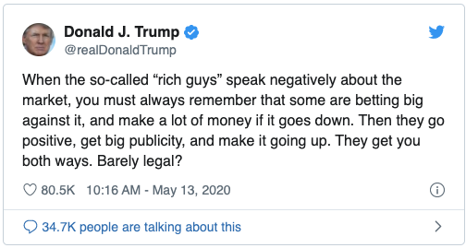

I know it’s easy to dismiss this as some crazy talk conspiracy theory…

But if you really think about it…

Isn’t it also the most simple, logical, and realistic reason why they ALWAYS seem to win…

And everyday people like ALWAYS seem to lose?

Backed by Credibility and Proof Elements | We’ve seen this happen before. 2002… 2008… 2015  Fear sets in -- fueled by the media -- and individual investors go into panic-selling mode…  Institutions fan the flames by going on TV and saying the sky is falling, all while they short the market, and profit all the way down...  Then, after clearing out the sellers...  They buy at the bottom...  Use the same financial media to help them drive the prices back up...  Dump their shares on individual investors like you who think they’re getting in on the “next big thing”…  ...and then rinse and repeat until they’re rich... and you’re ruined!  It’s the oldest trick in the book…  And it works pretty much every single time.

Mechanism / Solution
Now That You Know the Real Cause of the Problem, This is the “Real Solution” on a MACRO level.  This Should Be Logically Connected to the Problem [  For Example: If Bad Bacteria is Causing Your Weight Gain, the Solution is a Novel Way to Rid Your Gut of Bad Bacteria.] | But their proven plan has a fatal flaw…  And I’ve discovered a way to use it against them and potentially turn every $10k invested into a $1.2M fortune  They can’t buy billions of dollars of stocks in one shot.  If they did, they’d push the price back up too fast.  So instead, they have to continue to spread fear and panic for months…  And then sneak into position without anyone noticing.  But thanks to my proven investing strategy…  The F.A.S.T. Money Method…  I can see EXACTLY where the “Big Money” on Wall Street is moving to next...  Narrow it down to the best ETFs and individual stocks to play for the biggest, fastest, easiest, and safest gains…  Get my money in…  Wait for the ticker symbol to explode higher…  And cash out with a virtually guaranteed payday.  Which is exactly how I’ve been able to...
Once They Have the MACRO Solution (A Theory) – They Dig Deep To Prove The Theory (And Get Into The MICRO). | Legally spy on Wall Street's biggest moves…  And land some of the easiest, biggest, fastest, and safest gains in the markets today.  The strategy is simple…  We NEVER try to predict what's going to happen next in the stock market.  Instead, we use a proprietary data source – along with four important indicators – to see where the money is going.  We call this the “trend”…  Big institutional investors usually stay focused in their favorite sectors for months – or years – at a time.  And if you want to make gains the easy way…  Look for a trend and ride it for as long as you can.  Now, I already gave you a sneak peak at the first indicator we use to figure out where the trends are right now…
Indicator #1 | Indicator #1: The Bullish Percent Index  Remember this chart from earlier?  In the mid-1950’s, a guy named Abe Cohen invented something called the “Bullish Percent Index”...  ...or “BPI” for short…
What does it do? | And what makes this chart simply magical is how simple it is to use.  What it allows us to do is take a group of stocks… which in this example is the NYSE composite index…  And instantly know which direction the broader market is moving.  I think my favorite part is how clear the signal is from this indicator…  It strips away all of the unnecessary details that wind up screwing individual investors up…  And just gives us a clear “buy signal” or a “sell signal.”  This has to be one of the simplest, easiest, and most effective ways to reduce risk in all of existence.  Because if you can see the trend, and you just go with the flow, it’s like picking up free money.  But no one is getting rich by going long - or short - the broader market.  We need to get down to a specific stock or ETF.
Indicator #2 | This is where indicator #2 comes into play…  Indicator #2: “Sector Relative Strength”
What does it do? | This is how we drill down and find which sectors are going to make the biggest – and fastest – moves.  Here’s how it works…  At any given time, there are thousands of stocks that trade on the broader stock market.  And each stock is categorized into a specific sector.  There’s 11 sectors in total…  - Energy  - Basic Materials  - Industrials  - Consumer Discretionary  - Consumer Staples  - Healthcare  - Financial  - Information Technology  - Communication  - Utilities  - Real Estate  And inside each sector are multiple sub-sectors.  So, let’s say our indicators are telling us there's an opportunity in the Energy sector…  We could take a broad sector bet and invest in an ETF like XLE…  Or, we could look at all the subsectors inside of energy…  ...which are things like Oil & Coal, Electric, and Gas…  And use the ”Sector Relative Strength” to see which subsector is strongest relative to the rest of the stock market...  We can trim the fat and ONLY get in on the best performing subsector of that trend.  Normally, it’s a huge pain to figure this out manually using spreadsheets…  So I had some programmers build me a dashboard so I can see all of it quickly, easily, and at a glance...  Here’s what it looks like...  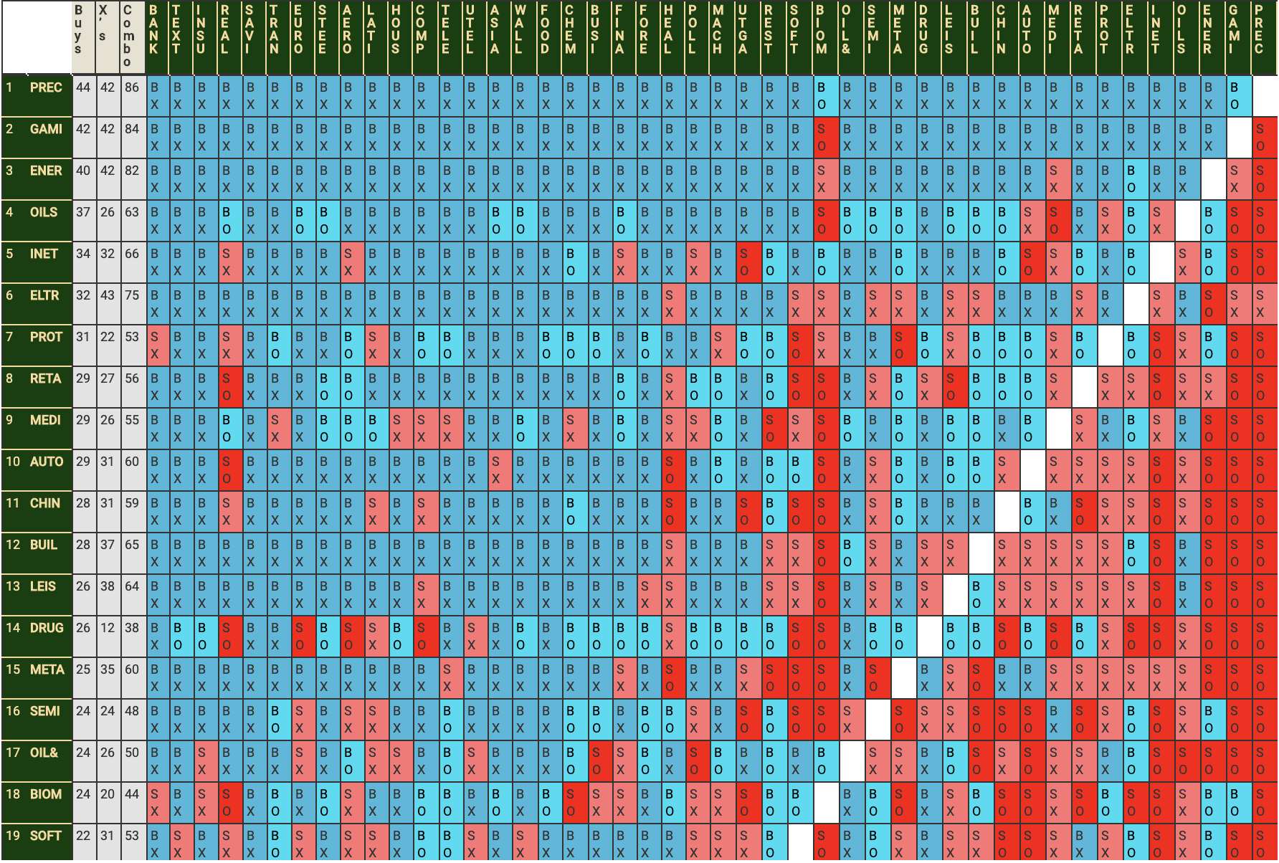  But knowing what to buy is only half the battle…  Because if you don’t know when to get in and when to get out…  You’re just guessing.
Indicator #3 | That’s where indicator #3 comes into play…  Indicator #3: The “%30”  Which is shorthand for “30-week moving average”
What does it do? | If you’ve never heard of that term before, no worries, it’s really simple to understand.  What this does is tell us how many stocks - in whatever sector we’re looking at - are trading above the average stock price from the last 30 weeks.  If more stocks are breaking above their 30-week moving average…  ...that’s a really strong signal to get back in the market.  If more stocks are starting to fall below their 30-week moving average...  ...that’s a strong signal to get out  So, if you’ve ever found yourself sitting on the sidelines wondering when to get back in…  Or you’ve ever felt nervous and wondered if you should get out…  This is the key to knowing what to do.  Seriously, if you’re not looking at this every day, you should be.
Quick Review | Alright so quick review…  The F.A.S.T. Money Method uses four powerful indicators to legally spy on Wall Street's biggest moves…  - We start by looking at the “Bullish Percent Index” to get a high level view of where the major trends are…  - Next, we use “Sector Relative Strength” to narrow our search down to the best performing sectors and subsectors…  - Then, we use the %30 to help us know when to get in and when to get out.  Now, if all you had were these three indicators, you’d probably do better than 99% of all individual investors right now.  But if we want to maximize our profit potential using this system…  ...and find the fastest, easiest, biggest, and safest gains in the market right now…  We want to trade ONLY the strongest stock in the sector.
Indicator #4 | That’s where the “7-1 month” indicator comes into play.  Indicator #4: The “7-1 Month”  And just like all of our other indicators…  It’s easy to understand… simple to use… and wildly effective.
What does it do? | Here’s how it works…  If you want to figure out what individual stocks are the best ones to invest in…  Generally speaking, you should buy stocks that are already outperforming other stocks in its sector…  And sell stocks that aren’t.  This is called “price momentum”...  And just like we learned in science class that “objects in motion will stay in motion, unless acted upon by an outside force”  According to a white paper published by a research group called GMO...  “The basic thesis behind [this indicator] is that leadership within the market persists for enough time that, on average, one can beat the market simply by rotating into stocks that have been outperforming.” [source]  But here’s the thing you need to know about stocks…  They don’t go up in a straight line.  There’s usually a “pull back” where the stock takes a slight dip before moving higher.  The “7-1 month” indicator tells us what stocks have shown the biggest outperformance over the last six months…  ...not including the previous 30 days.  Let’s take our energy example from earlier…  As you already know, oil got absolutely POUNDED earlier this year and was trading negative…  But that doesn’t all energy stocks are in the dump.  FuelCell Energy Inc has been on a tear according to the “7-1” indicator…  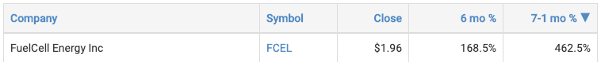  But check out the “6 month” indicator...  It looks like the stock took a pull back, and this could be a great chance to get in before it continues to move higher.
Summary | Now, just to be clear, this is not an official buy recommendation…  It’s just an example of this simple - but powerful - indicator can help us find our very best investment opportunities...  And help us get the best possible returns with the smallest possible risk.  That’s what makes The F.A.S.T. Money Method so effective.  And if you want to find the fastest, easiest, biggest, and safest gains in the market right now…  This is the ONLY system you’ll ever need!  All you need to do is make sure all four indicators say “buy”...  Get your money in…  Wait for the stock to move higher…  And get out when it says “sell”.  I know, I know…  It’s almost hard to believe it really could be this simple…  But thanks to this system…  I’ve been able to call almost every single major market top - and bottom - over the past two decades.

Product Buildup + Reveal
Track Record | In July of 2007, I recommended my readers...  “start going crazy buying put options on the brokerage firms, including Bear Stearns, Merrill Lynch, Morgan Stanley,”  ...along with about eight other financial stocks I recommended betting against.  Not even a year later, Bear Stearns went to zero…  Merrill Lynch and Morgan Stanley suffered huge losses...  And my subscribers had a chance to make a small fortune.  People like Sabrina S, who doubled her account during toe 08 crash...  “I profited from the stock market crash of 2008 when I turned my $85,000 account into more than $190,000.  –– Sabrina S.  On April 28th, 2008, I sent an update to my subscribers titled...“Commodity Massacre Starting Tomorrow?”  In it, I warned…  “TODAY is the time to check your portfolio and be very honest with yourself. Are you too heavy in commodities?  If the fed minutes cause a rally in the dollar, it could easily cause an intermediate term drop in commodities.”  At the time, the CRB Commodity Index was hitting new highs at $419.80 per share…  But soon after, commodity prices started tanking by more than 50%.  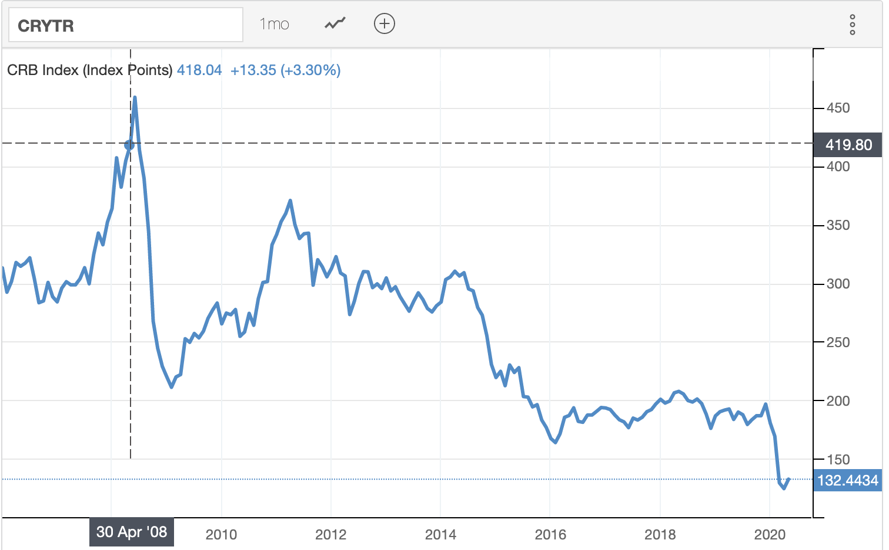  Sell!  And still, to this day, the index hasn’t even come close to reaching it’s 2008 highs.  On Tuesday, July 12, 2011, I sent out an alert warning of a “Major Market Top”…  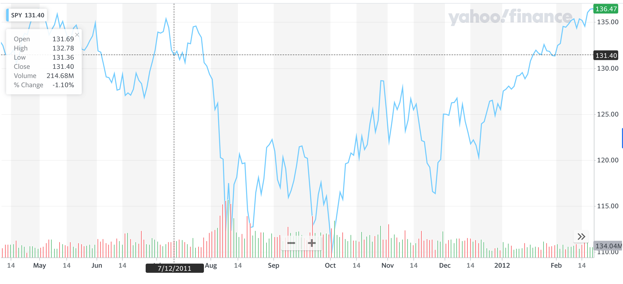  Sell!  Shortly thereafter, the SPY dropped more than 15% in a matter of weeks.  But then, on Tuesday, August 23rd, 2011, I told my readers the market looked “MEGA OVERSOLD” and it was time to get back in...  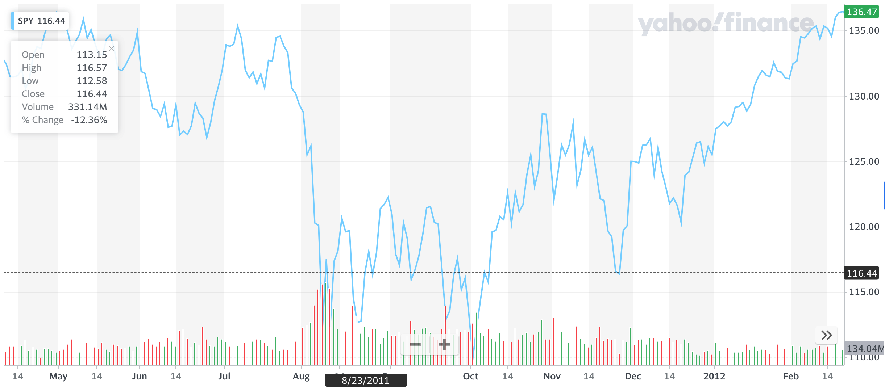  Sell!  Buy!  And even though the markets traded sideways for a few months…  The market marched up another 10% before hitting a new all time high in March of 2012.  October 15th, 2014, I called the bottom to the minute when I released my Q3 Market Outlook at 11:30am.  In it, I told my subscribers…  “Position yourself for an intermediate-term bullish rebound with responsible risk management to protect your downside if you’re wrong. We will probably find out quickly (within a month) if we are wrong about the oversold bounce. [source]”  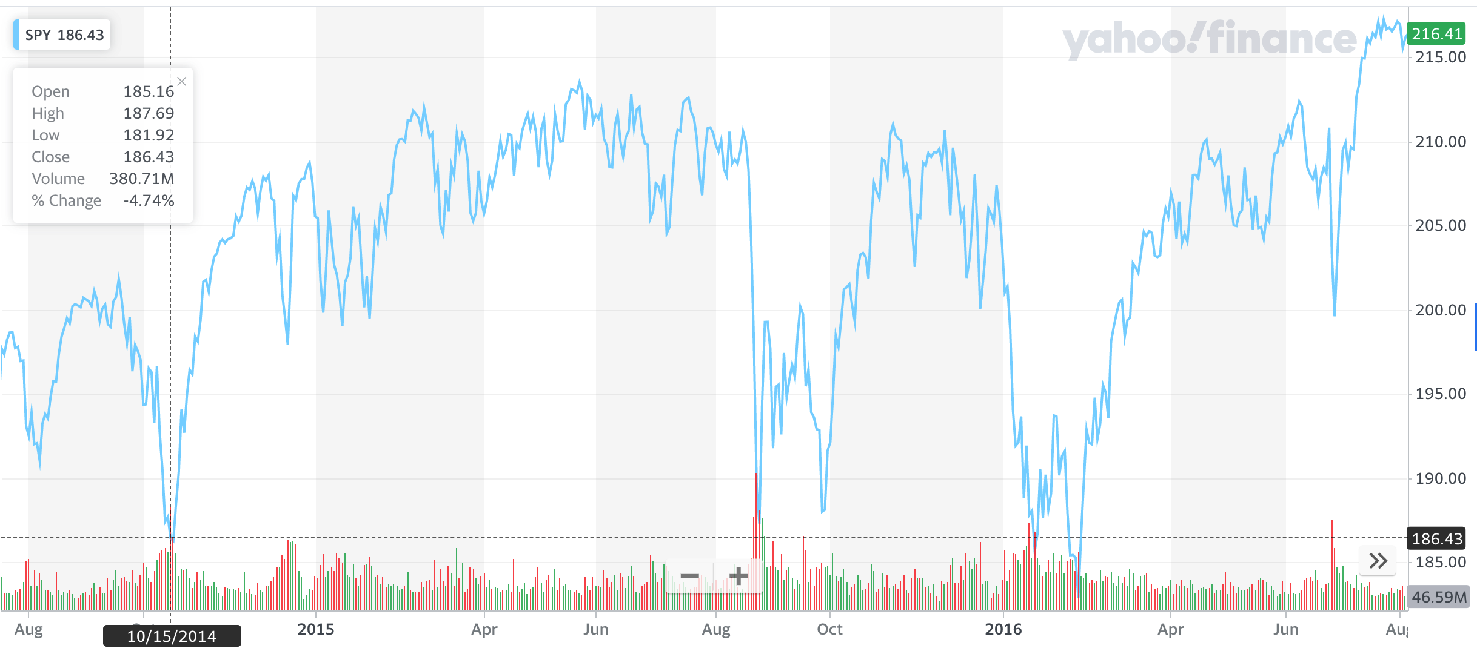  Buy!  And sure enough, we saw a huge rebound immediately after that went out.  On August 5th, 2015, I sent out an alert titled “Why 85% of All Sectors Look Bearish” where I warned of a coming correction.  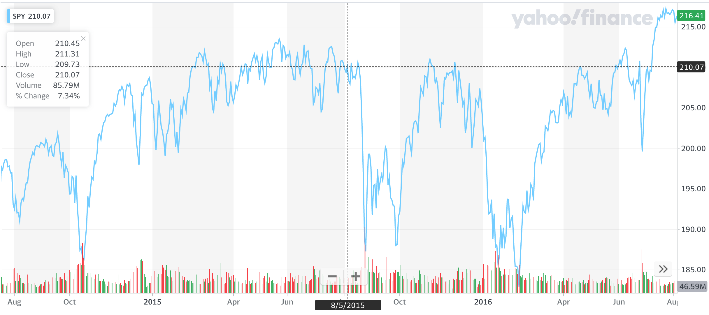  Sell!  Buy!  By August 31st… just a few weeks later… the Dow posted it’s worst August decline in 17 years.  Just a few months later on September 23rd, 2015, I sent out another alert to my subscribers warning “CRITICAL Market Signal - Last Seen at 2008 Low”…  “Any investor who listened to [this buy signal] back in late 2008 had a chance to buy the stock market at levels not seen since 1996! [source]”  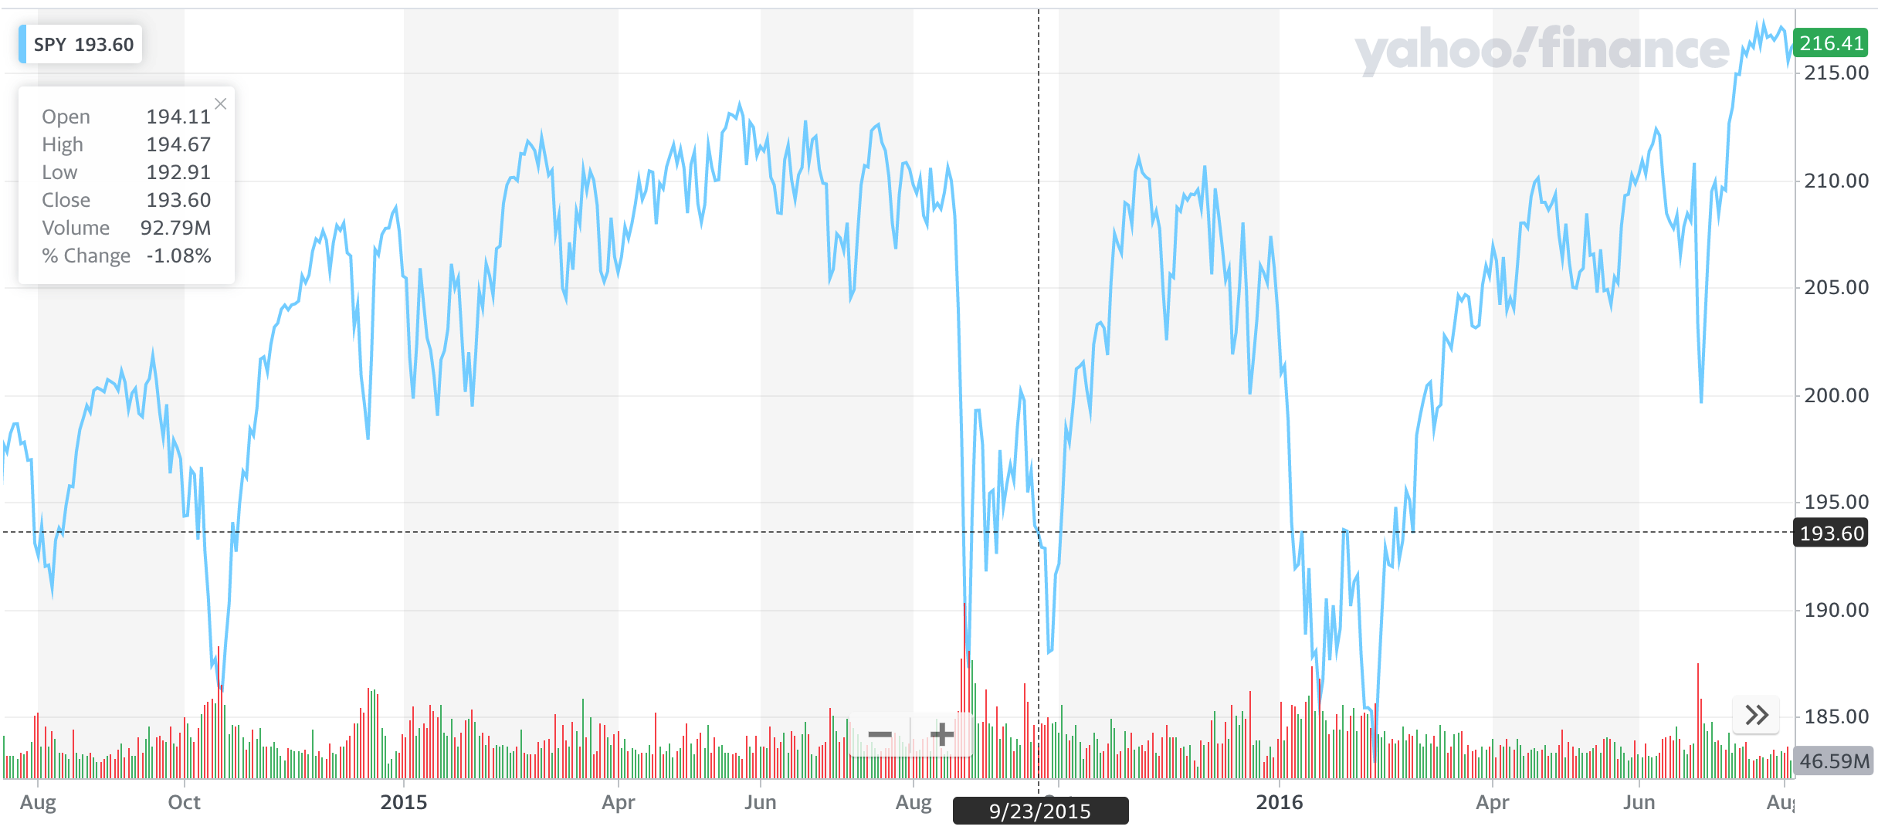  Sell!  Buy!  Buy!  On February 1st, 2016, I sent out an alert to my subscribers with a simple message…”Most Bullish Signal in 30 Years”  [This indicator] has reversed up, out of oversold territory.  Historically, this has proven to be a very bullish event, most of the time. And the bullish trend that follows is typically super strong. [source]  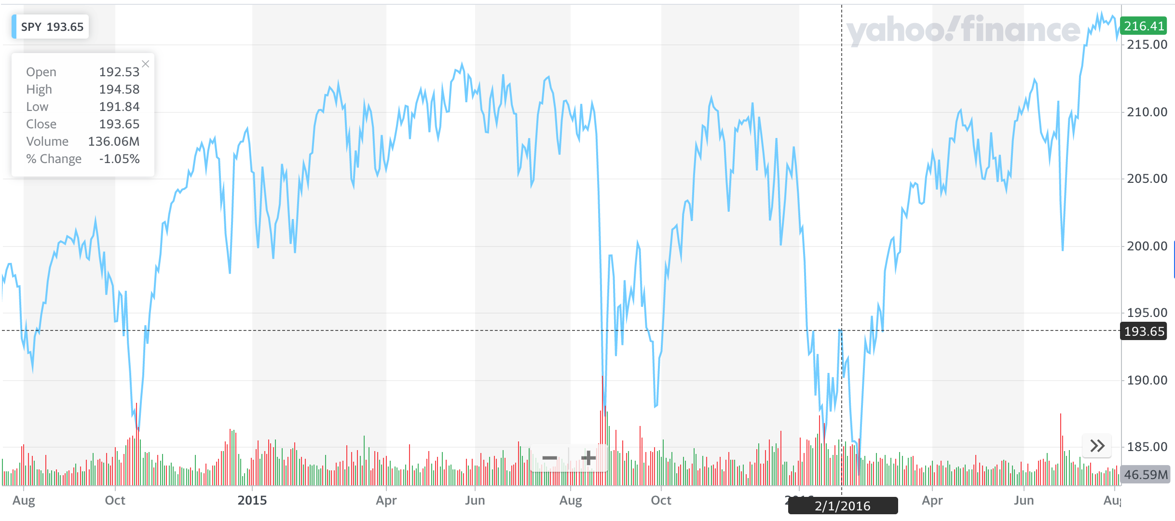  Sell!  Buy!  Buy!  Buy!  On January 29th, 2018, I sent out a warning… “Here's Why 2018 Could Turn Into 1987” [source]  Inside, I warned my readers...  The stock market of 1987, is eerily similar to today's.  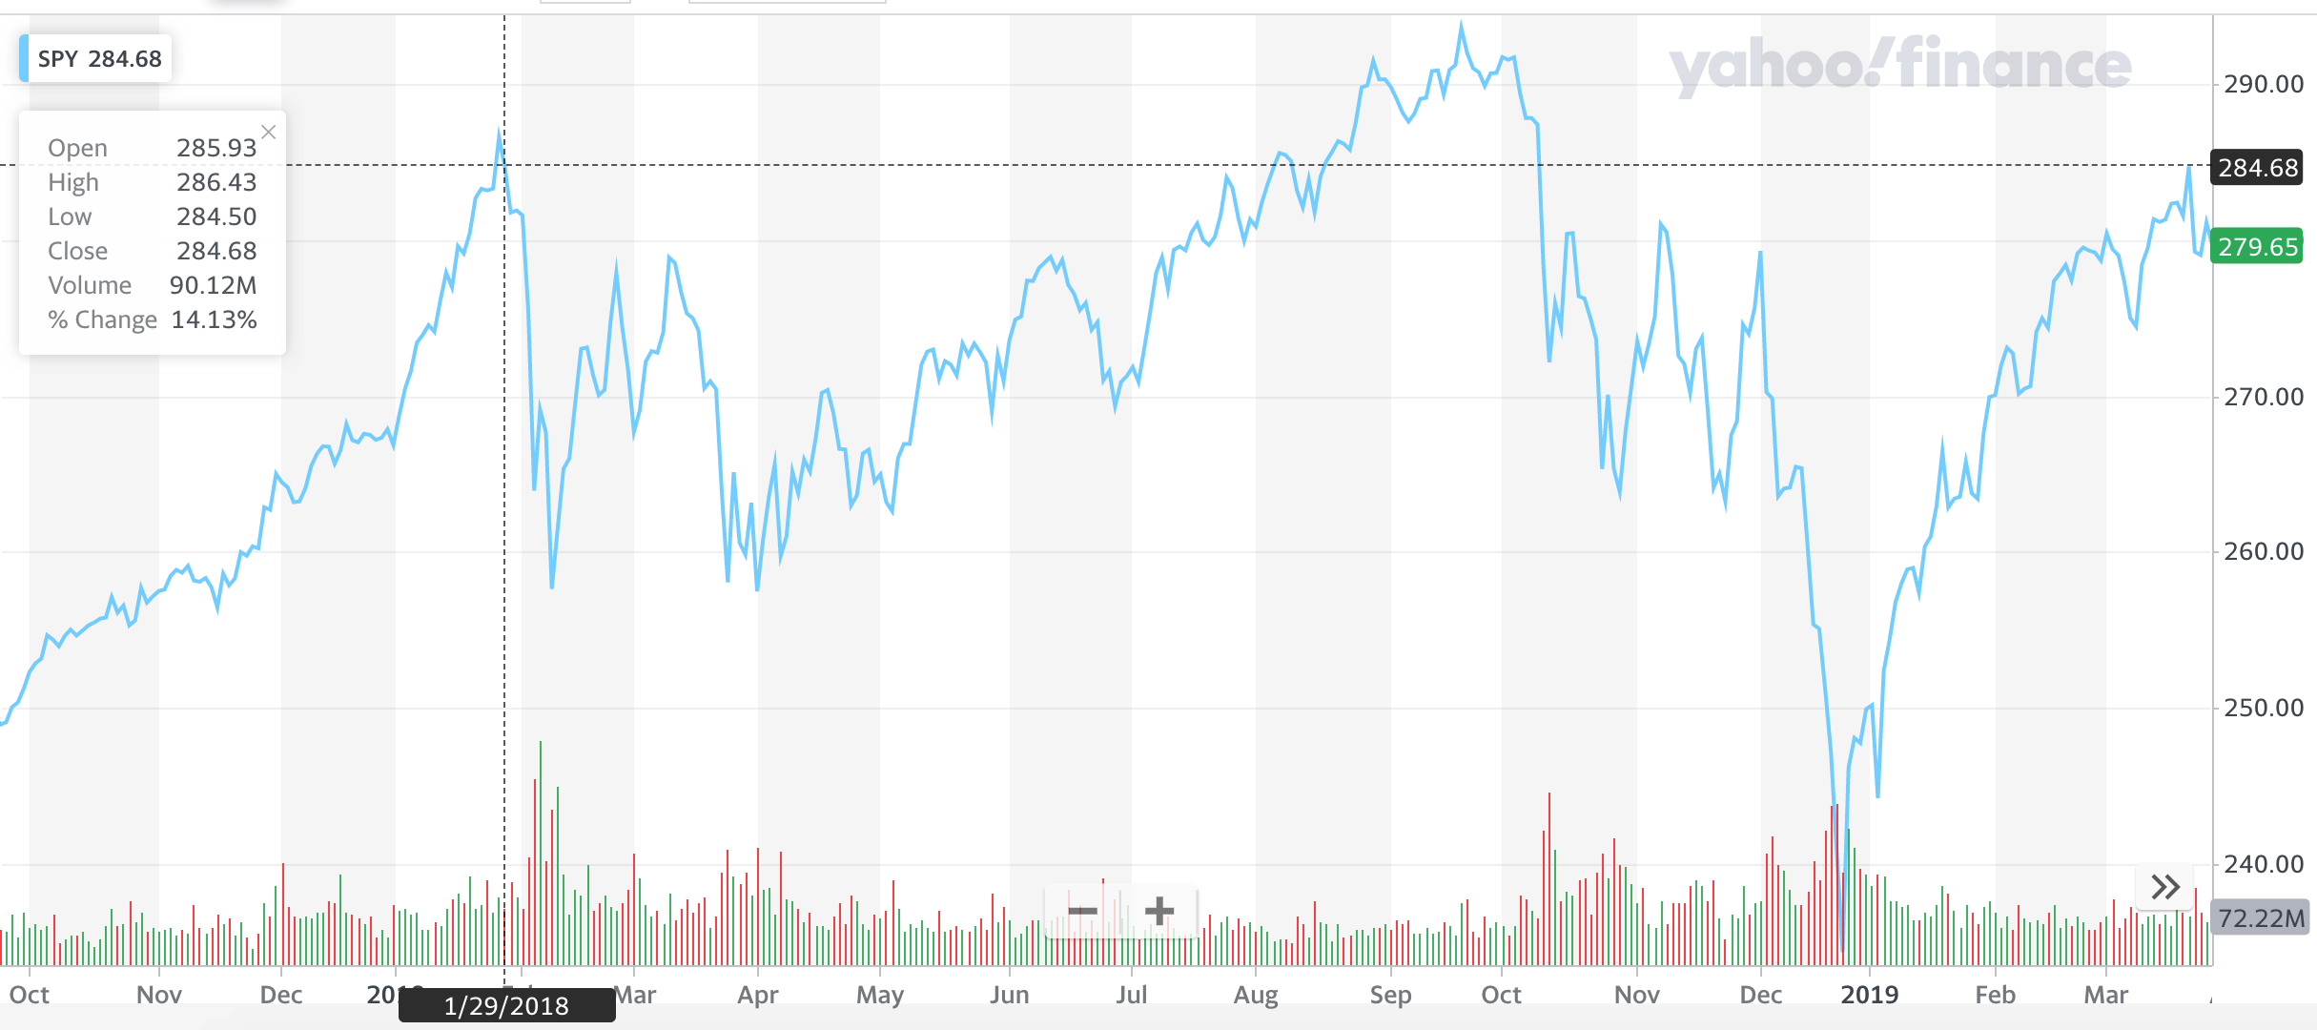  Sell!  The EXACT top - to the day - before the markets saw some of the worst - and fastest - losses in history…  In barely two weeks time, more than $1 Trillion in market cap was gone.  On April 12, 2018 my firm alerted our readers to what we believed was the best opportunity to get back in…  It had been nearly two-years since the S&P 500 declined by more than 10%, depriving investors any opportunities to buy high quality stocks at a significant discount.  Although investors have finally been dealt this opportunity to buy high-quality stocks at a bargain, the majority of them have suddenly turned reluctant.  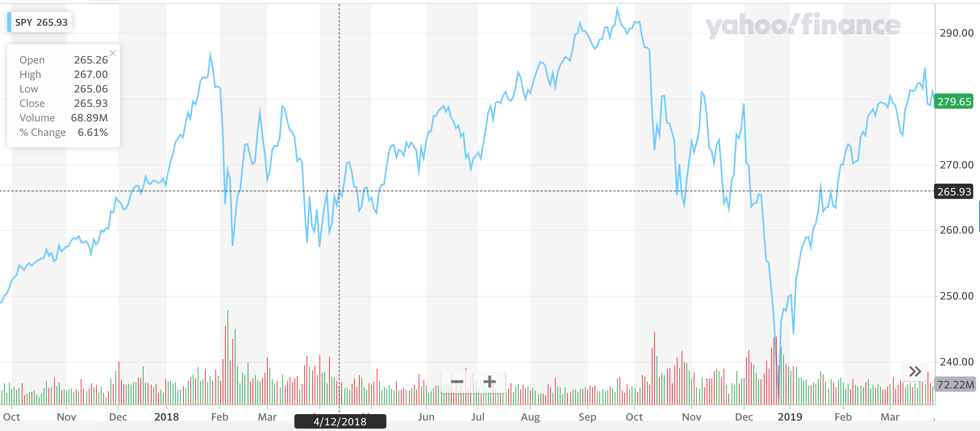  Sell!  Buy!  And I nailed it again on September 27, 2018 when I warned…  The market is poised for more downside, in the short-term. The S&P 500 is showing momentum sell signals, per it's RSI [source]  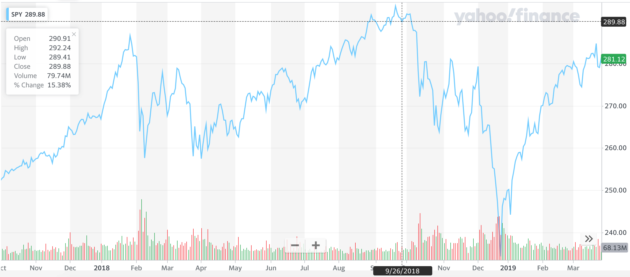  Sell!  Buy!  Sell!  On December 21st, 2018 I sent out an alert telling my subscribers…  “This Historically Washed Out Market Is A Huge Opportunity”  Not only did I almost “bottom tick” the S&P 500 with my call...  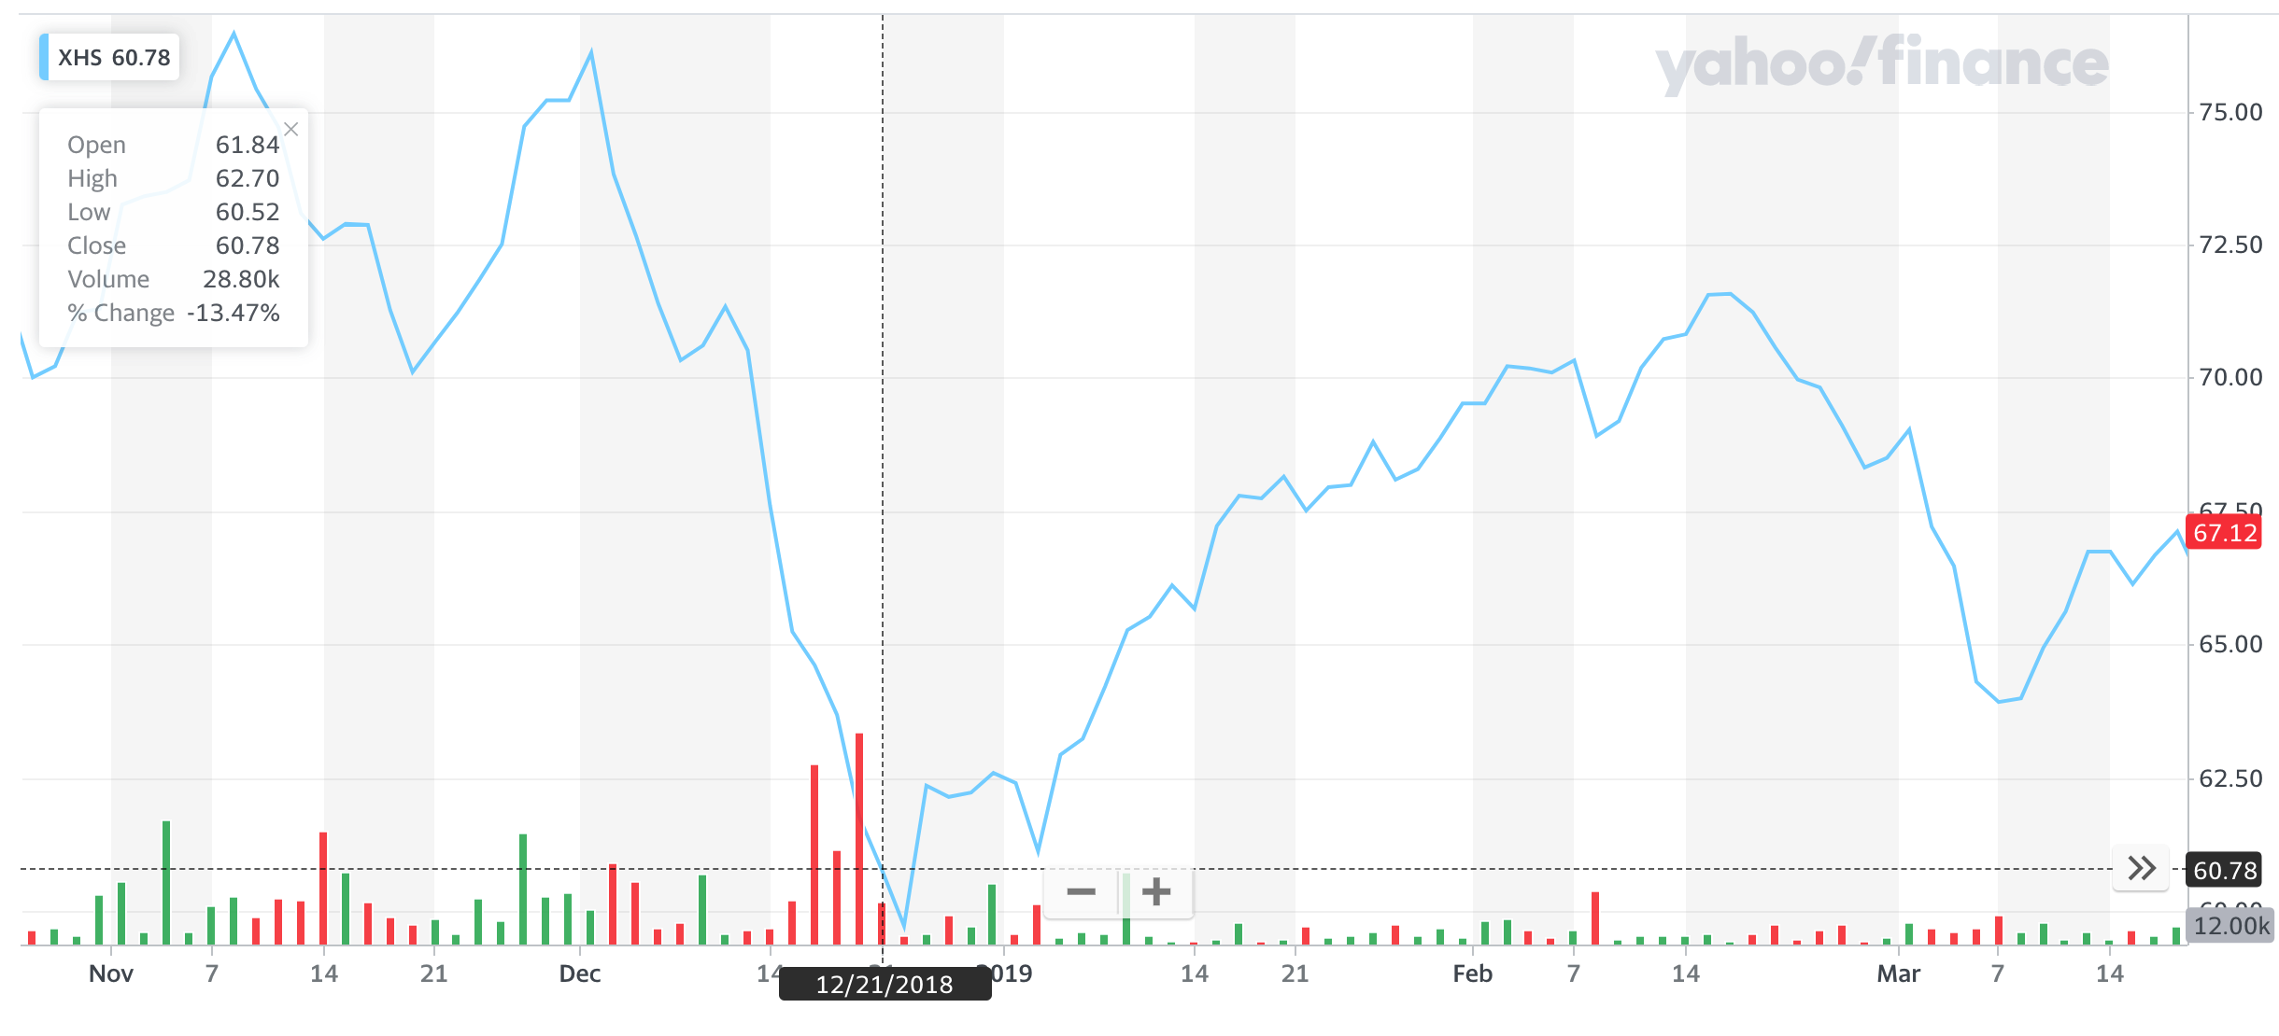  Buy!  But my “buy Healthcare” recommendation was spot on…  Here’s what I wrote to my subscribers  The sub-sector "Healthcare" has been gaining strength for most of the year, but lately it's sold off so hard that the readings show the sector as weak. But in a beaten down market like this one, this is the type of sector you want to own because the large institutions, who sold the sector short... are likely to cover their positions very quickly. This will cause a strong "short-squeeze".  Buy!  Sure enough, that’s exactly what happened.

Most people will tell you it’s “IMPOSSIBLE”
to make calls this accurate…
But over the past 25 years…

In every single market condition you can imagine…

The F.A.S.T. Money Method has given me an “unfair advantage” in the markets.

Was it just dumb luck?

Sure, I guess there’s always some sort of luck involved in any success you have…

But it’s a statistical impossibility to randomly get it this right, this often...

Did I have some sort of crystal ball that told me exactly when to buy and when to sell?

I’ll be the first one to admit I can’t predict the future…

And I think anyone who wastes their time “forecasting” what the markets will do next are con men (or just idiot economists).

Because when it comes to my money…

I don’t like to guess and hope I’m right…

I want a mathematical edge that practically guarantees I’ll be on the winning side of my trades.

And no, before you ask…

It’s not because of some silly breakout pattern the Guru’s try to wow you with in their presentations…

It’s something FAR more accurate than those could ever be.

So you have to ask yourself an important question...

Is it possible that there REALLY IS a
“secret market” most people can’t see?

And maybe… just maybe…

I AM one of the people who can see it…

And I CAN show people just like you how to profit from these hidden moves not 1 in 10,000 people know even exist?

And IT REALLY IS possible for you to double, triple or even 10x your portfolio over the next 3-5 years…

...explode your portfolio by more than TWELVE THOUSAND, FIVE HUNDRED PERCENT over the next 15-20 years…

...and have the chance of turning every $10,000 invested into a life changing $1,264,235.

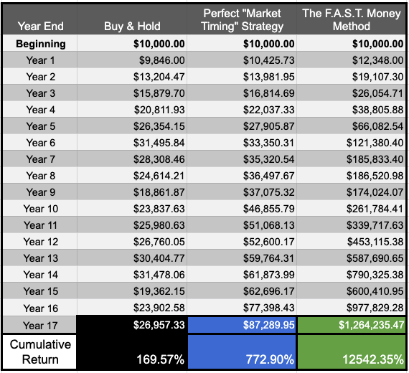

But here’s the important thing you need to know about The F.A.S.T. Money Method…

Does it work for people like me?  Testimonials | Thousands of everyday people JUST LIKE YOU have seen F.A.S.T. Money thanks to this breakthrough investing strategy.  People like Andy D, who’ve been burned too many times by other financial newsletters writes...  “I have subscribed to dozens of financial newsletters during the past ten years, usually with poor results.  Since starting my subscription in June my portfolio is up 46%, a darn good return for only four months. Keep up the good work.”  Or Robin J, who finally feels confident in her trades...  “[Chris Rowe helped me] by keeping me safe, which provides confidence. I own three stocks which are less than 4 months ‘old,’ and the gains are 29%, 34% and 62%. [The F.A.S.T. Money Method] is like wearing night vision goggles!  People like Frank F. who’ve doubled their account since they started using it...  “My portfolio is up over 100% since January 1st… increasing from roughly $23k to $50k is the first really spectacular success I’ve had in the stock market”  Or Bez B who doubled his account in one month after losing his job...  “In February, having lost my job in January, I paid some of my end of service money into my trading account and have doubled that value in one month. I am so grateful to Chris.”  Or Russel G who has almost tripled his account…  “Account has doubled and almost tripled. I need this for retirement”  And Keith B, who’s booked $40k in PROFIT in only six weeks...  “I am pinching myself to make sure this is actually happening to me. Even though I am still conservative with my trade size I've booked about $40K in profit over the last 6 weeks.”  – Keith B.  These people couldn’t be happier!  And hearing success stories like these ones are the reason I do what I do.  Which is why I want to get one from you when you’ve seen for yourself how powerful The F.A.S.T. Money Method can be.  Because I believe the next 6-9 months are going to be one of the single best opportunities for people just like you to make a fortune.
Why now | It’s the biggest opportunity I’ve seen  in my 20 years as a professional trader  But if you’re sitting on the sidelines hoping to catch the bottom…  Or you’re waiting for the “all clear” from the mainstream media…  You’re going to miss out on this once-in-a-generation opportunity that can change your financial future forever.  Because we’re only months away from the 2020 elections…  And even though I won’t pretend I can predict the future…  My Indicators Are Screaming “BUY NOW!”  The Coronavirus has created the perfect “cover” for the Wall Street insiders to make their move…  And if you know where they’re going…  You can follow them into these trades for some of the biggest, easiest, and safest gains you’ll ever see.  But the ONLY way to take advantage of this opportunity is to use The F.A.S.T. Money Method…  And the BEST way to start benefiting from this market beating system is to become a subscriber to my fully loaded data platform I call...

Close
Product Name | Sector Profits Pro
What is it? | If you’ve signed up for any other financial newsletter or stock trading service in the past… I want you to know that this is nothing like those.  Because I’m not in the entertainment business…  I’m in the results business!  And after more than 25 years of being a professional money manager…  If you want to consistently win in the stock market…  ...and make a more than full time income working way less than part time…  You need tools that help you save time, reduce stress, and make decisions…  NOT a dozen different gurus sending you random “stock picks” and hoping you get lucky.  That’s why I’ve invested more than a million dollars of my own money into developing this product.  I use this to manage my own money…  I use this to help me manage the hundreds of millions of dollars I have under management in my fund.  And I honestly can’t imagine being an investor WITHOUT Sector Profits Pro.  Because every single day, you’ll be able to log into the Sector Profits Pro website…  Instantly understand what’s really going on inside of today’s markets…  Find the very best profit opportunities almost no one can see (except for True Market Insiders like us)...  And you’ll finally have the confidence you need to manage your entire portfolio in just a few hours each week.  Which means you’ll have the chance to not only get market crushing returns…  But the freedom to actually enjoy your life.  Here’s what you get when you sign up today for Sector Profits Pro

Daily Sector Prophets Power Alerts

As we discussed earlier, The F.A.S.T. Money Method uses four powerful indicators to tell us WHERE to buy... WHAT to buy… WHEN to buy… and WHEN to sell.

Now, it’d be a huge pain in the butt if you had to manually figure this stuff out…

Or manage a ton of spreadsheets…

Or have to use multiple websites to get everything you need.

But with Sector Profits Pro…

You can login to the website and see what’s going on in every single sector…

Get notified by email whenever one of our indicators change…

And even cooler, it’ll show you what the top 3 ETFs and top 3 Stock opportunities are for that sector.

It looks like this…

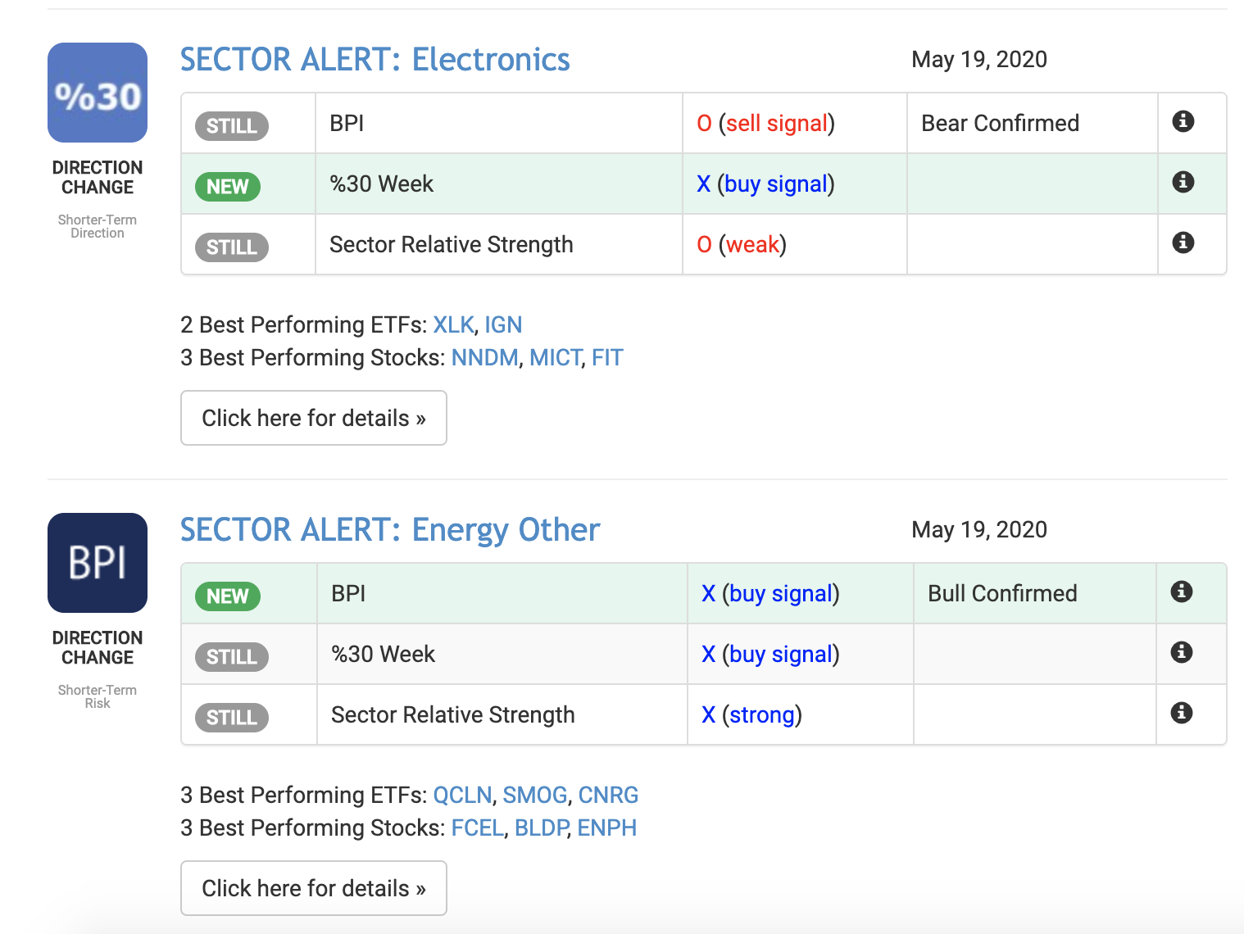

It’s basically gift-wrapping you high-potential winners!

So this brings up an important point…

You could literally just place trades, almost blindly using these alerts, and it could potentially work out well for you.

That’s the easy way to use Sector Prophets Pro...

Some members do that… but it’s NOT the best way!

You see, this program isn’t built to just give you the highest potential picks, and hope you make the best of it…

This program is built to educate you…

And the best way for me to help you “learn how to fish” so to speak...

...is to provide weekly commentary and analysis about what’s going on inside of the platform.

So what this means, in addition to the Daily Sector Prophets Power Alerts, you’re also going to get what we call our

Weekly Sector Prophets Spotlight

Each week, you’ll also get in-depth reflection on one of the alerts we gave during the week.

It looks like this…

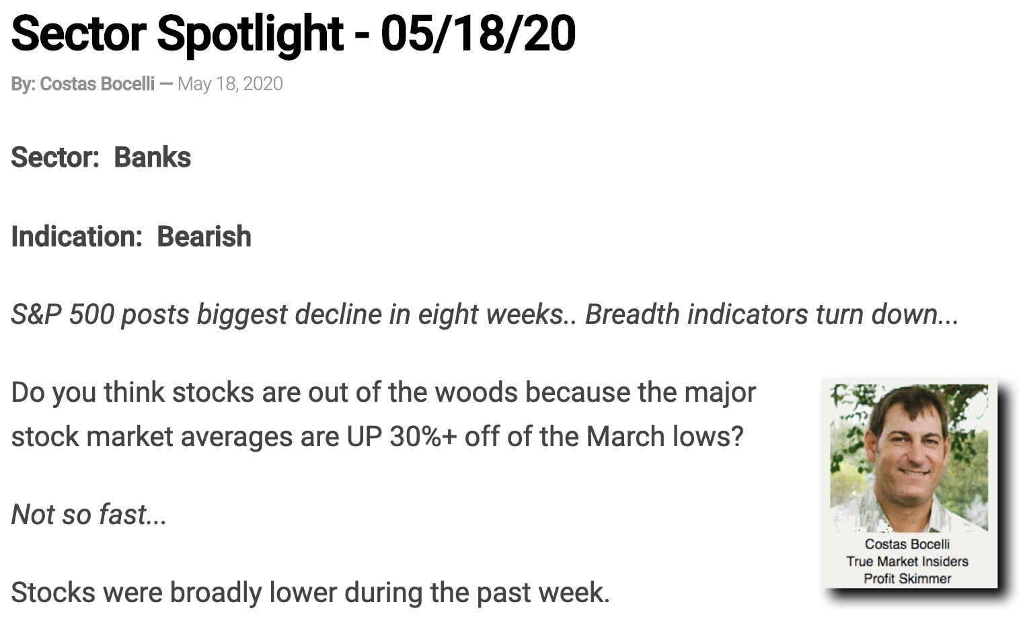

This connects the dots between “Here’s a great trade to consider”...

To “Here’s what happened with that trade and why.”

The Spotlight combined with our Alerts puts you into a cycle...

A cycle that gets you seeing opportunities, tracking them, seeing how they play out, and then analyzing that performance on a weekly basis.

All in all, this is going to help take you through your entire journey…

From “I’ve never traded stocks in my life”...

To “earning a full time income working less than part time”

Now, just a quick reminder, I can’t legally give you any personalized investment advice…

But what this lets me do is provide a level of “coaching” and feedback that can help you get better results using Sector Profits Pro.

And to help you get EVEN BETTER results, you’re also going to get...

24/7 Access to The Ultimate Sector Research Platform

If you’re the kind of person who loves to roll up your sleeves and really understand how things work…

You are going to LOVE this.

Because unlike those other guru’s who claim to have some magic algorithm that finds winning trades…

...but you have no idea what it is, how it works, or even it’s real…

You have full access to our proprietary research platform and can use it yourself, however often you’d like.

It looks like this…

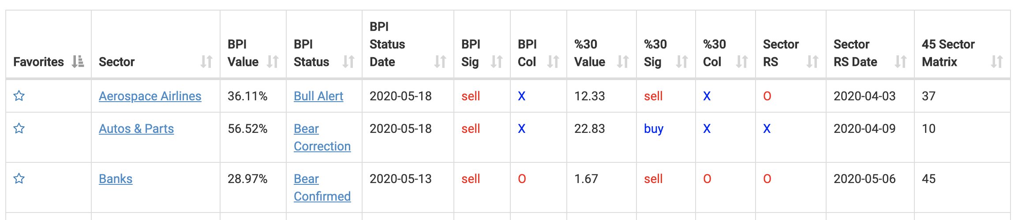

You can see everything in well organized tables…

You can click on the links to dive deeper into that particular sector or get more information on the alert being generated…

And you can customize it to only show your favorite sectors.
Trial Close + Testimonials | Can you see how simple and easy-to-use this is?  Can you imagine much more confident you’d feel having all of this at your fingertips?  Do you think you’d probably get way better results using Sector Profits Pro than whatever it is you’re doing right now?  It’s probably why we get so many glowing testimonials from our customers.  From people like Kenneth Burrell who says…  “My nightly routine is to look at Sector Prophets. Over the last 10 years, I've not found anything that comes close! Thanks for all you do.”  People like Robin J who says…  “Sector Prophets Pro is like wearing night vision goggles!”  People like Kevin R. who says…  “The service is the best I have ever gotten for so cheap. I’ve made a shit ton of money from it. I’ve found Chris to be the most honest person in the business as far as I can tell”  I gotta tell you, I love getting messages like these from our happy customers.  Because I’m thankfully in a position where I don’t need to work another day if I didn’t want to…  But I get up and work my butt off because I know what I’m doing is making a real difference for real people.  And I want to make sure you get the best possible results when you sign up for Sector Profits Pro today…  Which is why I’m also going to give you...

24/7 Access to Our 11 Professional Tools
This is what separates the sector traders that “get it” from the ones that DO IT.

And if you’re the kind of person who wants to make a more than full time income with a less than part time effort…

You need to have professional grade tools that help you save time, reduce stress, and make decisions.

That’s exactly what these are for.

We’ve got tools and specialized calculators for…

- Position Size
- ETF Listings
- Open & Closed Equity
- Historical ATR
- Major Index Breadth
- Sector Breadth
- All BPI’s
- E.W. Sectors / Sector RS / Matrix History
- Sector RS Matrix
- Options Quotes
- Options

But you still need one more thing… Something to keep track of it all!

That’s why your account ALSO comes with...

The Sector Prophets Position Key

The Position Key is exactly what it sounds like...

It keeps track of your positions.

You can put in positions you actually hold to match our platform with your exact account...

Or put in hypotheticals so you can track positions freely...

This lets you get more engaged with the sectors, it gets you accountable, and it gets you trading.

Alright, I know that was a lot of stuff, so here’s...
Summary | A quick summary of everything you get when you sign up for Sector Profits Pro today  - Daily Sector Prophets Power Alerts -- This is the Holy Grail for Sector Traders! Each week, you’ll get SIX of our highest conviction trades… along with a basket of alerts designed to help you spot the fastest, easiest, biggest, and safest gains in the market today.  - Weekly Sector Prophets Spotlight – Each week, you’ll also get in-depth reflection on one of the alerts we gave during the week. This connects the dots between “Here’s a great trade to consider”, to “Here’s what happened with that trade and why”  - 24/7 Access to The Ultimate Sector Research Platform – Not only will you get all the alerts and all of our commentary... you’ll also get access to our entire research platform so you can find even more trade ideas.  - 24/7 Access to Our 11 Professional Tools – Position Size, ETF Listings, Open & Closed Equity, Historical ATR, Major Index Breadth, Sector Breadth, All BPI’s, E.W. Sectors / Sector RS / Matrix History, Sector RS Matrix, Options Quotes, Options...This is what separates the sector traders that “get it” from the ones that DO IT.  - The Sector Prophets Position Key – You can put in positions you actually hold to match our platform with your exact account, or put in hypotheticals so you can track positions freely. This lets you get more engaged with the sectors, it gets you accountable, and it gets you trading.  It’s literally everything you need - at your fingertips - to become a profitable trader…  And earn a full time income working less than part time.  But let’s cut to the chase and talk about...
Price Justification & Reveal – Other “Solutions” Are More Expensive & Consequences of Inaction are Costly (Cost Can Be Either Material or Immaterial) | How much does Sector Profits Pro Cost?  Sector Prophets uses a lot of the same technology used by the world’s biggest hedge funds.  And if you’ve ever heard of the Bloomberg Terminal...  ...which is the industry standard data platform…  You already know it costs more than $24,000 per year for a subscription.  And that’s just ONE of the data platforms and algorithms the Wall Street bankers have at their disposal.  My company invests six-figures every single year just to get access to the market data we use inside Sector Profits Pro…  ...data that helps us legally spy on Wall Street's biggest moves and land some of the fastest, easiest, biggest, and safest gains in the markets today...  And I spend multiple six-figures every year for our team of analysts who help interpret the data and write all of the commentary.  So I think it’d be pretty reasonable to suggest that Sector Profits Pro is worth at least 10,000 per year.  But whenever I’m buying anything…  The real question I care about is what is it worth TO ME.  So, I want you to ask yourself right now…  What would it be worth TO YOU if you could consistently land double digit – and triple digit – winners?  What about having the confidence to manage all of your investments on your own…  ...and never have to pay a financial advisor 1% to manage your money for you?  What would it be worth if year in, year out…  You were making a full-time income from your investments…  WITHOUT taking huge risks that make you feel anxious, stressed out, and constantly worried you could lose it all in mere minutes...  WITHOUT having to constantly monitor the markets every day and be ready to trade at a moment's notice…  And WITHOUT having to sacrifice the lifestyle you want to live… or be forced to move to a third world country... because that’s all you can afford?  What would it be worth to you if you had results like some of our customers have already gotten?  People like Frank F. who’ve doubled their account since they started using this strategy...  Or Bez B who doubled his account in one month after losing his job...  Or Russel G who has almost tripled his account…  Keith B, who’s booked $40k in PROFIT in only six weeks...  And Jay W. who’s up $79,600…  I’m sure $10,000 would still be a bargain.  $5,000 would be even better.  $3,000 would be a complete steal… and that’s actually what I normally charge for an annual subscription to Sector Profits Pro.  And it’s worth every single penny.
This Solution is Better and Will Save You Money, It’s Normally $X Which is Bargain, But Right Now You Can Get It For Just $Y! | Because once you’ve got Sector Profits Pro…  You can say goodbye to all of those overpriced newsletters who do nothing but send you losing picks each month…  You can get rid of the other data services you’re signed up to, cause you don’t need them anymore…  And you can say goodbye to making unnecessary mistakes that lead to unnecessary losses.  But if you’re one of the first 150 people to order through this special promotional offer...  I’ll give you 12 months access for only $1,497!  That’s more than $1,500 off the retail price!
Smart People Buy More | But here’s the thing about Sector Profits Pro…  Like all things in life…  Your biggest gains will always come from compound returns.  Which means the longer you use Sector Profits Pro…  And the more often you’re hitting those sweet double digit - and triple digit - winners…  The faster your portfolio will grow.  When you order today through this special offer...  I’m going to lock in your annual subscription at the promotional rate of $1,497…  Which means every 12 months, your credit card will get charged $1,497.  Now, I’m totally fine if you want to do that…  But the smart people are gonna go ahead and sign up for the LIFETIME MEMBERSHIP for only $2,497.  Which means for less than the cost of two years of Sector Profits Pro…  You can get LIFETIME ACCESS and never pay another fee for this service.  But I’m only gonna let the next 50 people in for that low of a price…  So if you want to get the best possible deal I can afford to give you…  Make sure you signup for LIFETIME ACCESS – right now – before someone else takes your spot.
First Call to Action | To get started, all you have to do is click the button below.  YES! Sign me up for Sector Profits Pro
What Happens After You Click The Button | Once you do, you’ll be taken to a secure order form where you’ll be asked for all the usual stuff…  Your name, your email address, and your billing information.  Once you’ve filled out that form, all you gotta do is his the button at the bottom of the screen to complete your order…  And once your transaction has been processed…  We’ll send you an email with your receipt…  Login instructions to access the website…  And an invitation to one of our weekly “new member” webinars to help you get familiar with everything you have access to.  Which also includes...

BONUS Training Videos & Weekly Webinars
Every week, me - or a member of my team - hosts a private webinar for all of our Sector Profits Pro members.

We’ll talk about what’s going on in the markets…

Talk about new trade ideas and give updates on past recommendations…

Teach you something new that’ll make you a better trader…

And whatever else we can do to make sure you’re getting the most out of your membership.
Guarantee – You’ll Most Likely Have a Great Experience, But If For Any Reason You Don’t, No Risk and No Hassle | You’re also backed by my 60-day,  100% money back guarantee  You’ll have a whole month to enjoy Sector Focus, study my past issues, dip your toes into the waters based on the analysis you’ll get from my team and I.  Most importantly, for the next 60 days you’ll know exactly where to put your investment capital for the biggest potential profits…  The most promising stocks and ETFs in the strongest sectors...capable of handing you returns of 256%...340%...487% and even more.  The recommendations you’ll get are completely unbiased... untainted by pie-in-the-sky predictions or down-in-the-dumps news reports.  They’re based on the ONE AND ONLY factor that determines the price: supply and demand.  That means for the next 60 days, you’ll know -- really know -- that your money is in the places most likely to increase your wealth -- and least likely to evaporate.  You can enjoy the confidence and peace of mind that comes along with that knowledge.  Then, after you’ve had the entire Sector Profits Pro experience, if you decide it’s not for you -- no problem.  Just let our customer service team know within 30 days and you’ll get every penny back.  And remember: if you decide to keep going (which I think you will)...  I’ll be locking in your deal today, so you’ll only pay $1,497 a year for as long as you decide to keep your membership.
Second Call to Action | To get started, all you need to do is click the button below.  YES! Sign me up for Sector Profits Pro
Two Choices – You Can Go On Suffering, Or You Can Take Action Today and Change Your Life forever; The Choice Is Yours | Look…  In life, you’re always going to be faced with choices.  If you’re not happy with the way things are going in your life right now…  You can choose to do nothing…  ...and if you do, not only will things NOT get better, but they’ll probably get worse.  Or, you can choose to take action today…  Arm yourself with the tools and training you need to make more money in the markets…  And charge your life forever!  I can’t force you to do something you don’t want to do.  Because at the end of the day…  Only you can decide.  And look, I get it…  $1,497 isn’t pocket change.  But compared to the money you’re losing trying to manage your portfolio on your own…  ...and the gains you’re missing out on by not having Sector Profits Pro at your fingertips…  It’s a drop in the bucket.
Urgency 2 – But You Really Must Hurry As This is The End of the Presentation And There’s No Guarantee How Long Offer Will Be Available | Remember…  You have a full 60 days to try out Sector Profits Pro.  This means if at any time, you decide this isn’t for you, just let us know!  Why am I doing this?  Because almost every single person that tries Sector Profits Pro sees the results and wants to stick with us.  This is the real deal and we’re not afraid to make an ironclad 60-day money-back guarantee.  But really, you need to hurry up and order right now…  I’m only accepting 150 new annual members at the discounted price of $1,497…  And I’m only accepting 50 new LIFETIME members at the discounted price of $2,497.  I’m already seeing orders come in…  So if you don’t sign up now…  You might miss your opportunity to lock in this promotional rate.
Third Call to Action | Again, all you have to do is click the button below.  Once you do, you’ll be taken to a secure order form where you can enter all of your information.  After your order is complete, you’ll get an email with your receipt…  And login instructions so you can start using Sector Profits Pro right away.  YES! Sign me up for Sector Profits Pro
Thank You For Watching or Reading | Thanks again for watching this presentation.  I’m looking forward to having you as one of our newest members.

FAQ
Q1) What is The F.A.S.T. Money Method?

It’s the ONLY method I’m aware of that can help everyday investors quickly double, triple, or even 10x their portfolio over the next few years…

Explode their portfolio by more than TWELVE THOUSAND, FIVE HUNDRED PERCENT over the next 15-20 years…

...and have the chance of turning every $10,000 into a life changing $1,264,235.

Which means it doesn’t matter if you’re still trying to figure out how to save enough to afford retirement…

Or you’re retired right now and you’re looking for extra income…

The F.A.S.T. Money Method can help you get the kind of returns you need to retire early, retire now, and stay retired forever.

Q2) How is it possible to make that much money, that fast?

If you listen to all of the conventional wisdom about investing, they’re gonna tell you to do stuff like…

“Stick your money into a low cost index fund and just keep adding more until you retire.”

Now, I dunno about you… but that “buy and hold” nonsense sounds like crazy talk to me.

Especially if all I’m gonna get is somewhere between 5% - 10% a year in returns.

Because everyday people – just like you – can grow their accounts by 20%, 50%, even 100%+ every single year…

And do it by taking the SAME amount of risk – or LESS RISK – than traditional buy and hold.

How?

Well, instead of being invested in the entire market all the time…

We’re going to move our investments in to the sectors most likely to outperform… and out of the sectors most likely to underperform.

And how do we know what those sectors are?

Thanks to The F.A.S.T. Money Method, we can actually “spy” on Wall Street’s biggest moves before almost anyone knows they’ve happened…

And effectively “front run” their trades for what could be the fastest, easiest, and safest gains in the markets.
Q3) Why do you know this?

I got my first job on Wall Street when I was 17 years old…

And I was mentored by someone who was worth literally hundreds of millions of dollars.

It’s the same strategy that helped me become a millionaire in my early 20’s…

It’s the same strategy I’ve used for decades to manage my clients money…

And after 25 years of refining and perfecting it, I’ve turned it into an “easy-to-learn” system anyone can use.
Q4) If this is such a good opportunity, why don’t you raise a fund and be a gazillionaire?

Good question.

Here’s the short answer...
I already manage hundreds of millions of dollars through my other company, Rowe Wealth Management.

Again, that is a totally different company and has nothing to do with this offer at all…

But just to prove the point…

I “eat my own cooking” when it comes to investing.

If you’re wondering why I’m telling you - the “little guy” - about this, the answer is pretty simple…

Giving personalized investment advice isn’t very scalable…

Which means if I want to help a LOT of people, the only good way to do that is to create processes, procedures, and systems.

That’s why I developed The F.A.S.T. Money Method…

And that’s why I built Sector Profits Pro.

Q5) How is this different from anything else I’ve seen?

This isn’t like those other trading services where they tell you all about their magical trading system…

...but they only give you a couple alerts each month and hope it works out.

When you sign up for Sector Profits Pro…

You get access to all the same professional grade tools I’ve invested millions of dollars creating…

Weekly Sector Commentary where we review one of the previous weeks alerts...

PLUS! Weekly “members only” webinars where I’ll keep you updated on all of our open positions…

What’s going on in the market…

And I’ll answer any questions you have (or any trade ideas you’re looking at)

But here’s the biggest difference…

The F.A.S.T. Money Method isn’t some hypothetical “back tested” trading strategy…

It’s how I personally became a stock market millionaire in my early 20’s…

It’s what I use to manage hundreds of millions of dollars for my clients inside my wealth management company (which is a totally separate business, just to be clear).

And it’s the same strategy I’ve been teaching individual investors to use for more than 20 years now.

Long story short, this strategy freaking works!

And Sector Profits Pro is the software tool I created to help everyday investors implement these strategies in their own portfolio.

Q6) How do I know this works?

Thousands of everyday people JUST LIKE YOU have seen incredible results thanks to this breakthrough investing strategy.

People like Andy D, who’ve been burned too many times by other financial newsletters writes...

“I have also been playing the market for a long time (stocks since 1961 and options since 2000) and have made and lost a lot of money during these 46 years. I have subscribed to dozens of financial newsletters during the past ten years, usually with poor results.
I am happy to say that you have supplied a good percentage of winners with [The F.A.S.T. Money Method].”
Since starting my subscription in June my portfolio is up 46%, a darn good return for only four months. Keep up the good work.

Or Robin J, who finally feels confident in her trades...

“[Chris Rowe helped me] by keeping me safe, which provides confidence. I own three stocks which are less than 4 months ‘old,’ and the gains are 29%, 34% and 62%. [The F.A.S.T. Money Method] is like wearing night vision goggles!

People like Frank F. who’ve doubled their account since they started using it...

“My portfolio is up over 100% since January 1st… increasing from roughly $23k to $50k is the first really spectacular success I’ve had in the stock market”

Or Bez B who doubled his account in one month after losing his job...

“In February, having lost my job in January, I paid some of my end of service money into my trading account and have doubled that value in one month. I am so grateful to Chris.”

Or Russel G who has almost tripled his account…

“Account has doubled and almost tripled. I need this for retirement”

And Keith B, who’s booked $40k in PROFIT in only six weeks...

“I am pinching myself to make sure this is actually happening to me. Even though I am still conservative with my trade size I've booked about $40K in profit over the last 6 weeks.”

– Keith B.

These people couldn’t be happier!

And hearing success stories like these ones are the reason I do what I do.

Personally, I can’t wait to get one from you once you’ve seen for yourself how powerful The F.A.S.T. Money Method can be.

And the best way to make that happen is to go here get you signed up for Sector Profits Pro.

Q7) Do you have a guarantee?

Legally speaking, I can’t guarantee you’ll get the kinds of returns some of my subscribers have reported.

In fact, I can’t legally guarantee you’ll make any money at all if you sign up for Sector Profits Pro.

But here’s what I can guarantee…

You won’t get ANY results with Sector Profits Pro if you don’t have it.

That’s why I’m giving you a full 60 days to try it out for yourself.

If for any reason you’re not happy with the product and you want a refund…

All you have to do is email our customer service team at 855.822.0269 or email us at info@truemarketinsiders.com

Q8) How much do I need to know about investing?

You don’t need any prior knowledge or experience.

In fact, in many cases, the less you know about investing the better.

Why?

Because sometimes, experienced investors make the worst students.

They’ve already developed bad habits and think they “already know” how to do things (when they really don’t)

But beginners come into things with an open mind…

And are willing to try something new before deciding “this won’t work for me.”

Q9) How much do I need to get started?

Now, just a quick disclaimer, I am in no way shape or form making a recommendation about how much you should invest…

All forms of investing carry some sort of risk and you shouldn’t invest any money you can’t afford to lose.

But if you’re gonna invest the money to sign up for Sector Profits Pro… you’re probably gonna want to have at least $5,000 available.

And if you don’t have enough “dry powder” to trade with, you might miss out on some great opportunities.

Q10) Do I need a special brokerage account?

No, you don’t need any sort of special account!

I personally use the Think or Swim platform… but any major US brokerage account will work just fine.

We’re not buying any penny stocks, highly leveraged etfs, or doing any exotic options trades.

Sometimes I’ll recommend buying a call option or a put option…

But for the most part, we’re going “long only” on mid-cap to large-cap stocks... and ETFs that have plenty of liquidity.

So, as long as you can do that in your account, you should be fine.

Q11) Can I use this in my IRA?

Yes! You can use this strategy to help you manage any investment account you have.

If you’ve got an IRA, 401k, a 529 plan, or any investment account where you have access to things like stocks, bonds, and mutual funds…

You can use this strategy - and all of the resources inside Sector Profits Pro - to help you get better returns with less risk.

Q12) Are you shorting stocks in this service?

The last thing you want to do is take tons of leverage with infinite downside…

For that reason, we don’t make any “short sell” recommendations in this service.

We’ve found it's much easier - and safer - to use an inverse ETF or buy a simple “put options.”
 | YES! Sign me up for Sector Profits Pro

